Westfield parish council
The Oval Office, St Peter’s Business Park
Westfield, BA3 3BX
Phone: 01761 410669
Email: council@westfieldparishcouncil.co.uk
Chairman: Cllr G Fuller Parish Clerk: Ms L J Close FSLCC Established 2011

WESTFIELD FRONT GARDEN COMPETITION
ENTRY FORM 2021
YOUR DETAILS
Name:
Telephone Number:
Email Address:

Please tick category(s) you wish to enter:-

- Best Front Garden

- Best Container – including tubs, planters and hanging baskets
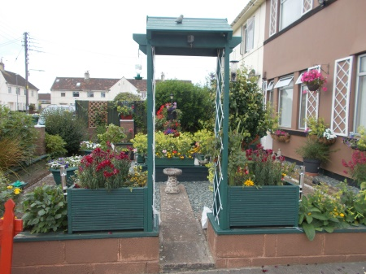
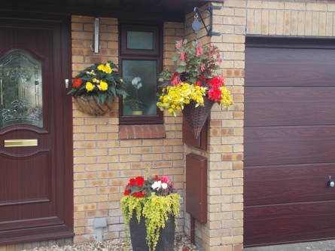
Please give the address of the nominated garden/container:
Address :

Is this your garden/container? Yes/No

Does the owner of this garden or container know that you have nominated them? Yes/No

Last year’s winners

