Grateful thanks to Westfield Primary
2017
We are pleased to release for public consultation our Neighbourhood Plan Options document.
We have formed this based on the information we have gathered from our earlier discussions with both local residents and businesses.
Completing the entire form takes about 40 minutes, but you can pick the areas that interest you, such as housing or green space and just give 5 or 10 minutes if you prefer. All responses are gladly received. Thank you.

Westfield Neighbourhood Plan Options Consultation
School for the logos.
WHAT IS THE OPTIONS DOCUMENT?
This is an initial draft of the policies which the Westfield Neighbourhood Plan Working Group feels would be appropriate for inclusion in the Westfield Neighbourhood Plan, based on all the evidence gathered to date. It can be read in conjunction with a Background Paper which is on our website at www.westfieldparishcouncil.co.uk or the Background Paper can be sent to you on request, please ring us on 01761 410669.
WHY SHOULD I RESPOND?

Producing a Neighbourhood Development Plan provides an exciting opportunity for communities to become directly involved in planning policy. A Plan allows the local community to create a vision and planning policies for the use and development of land in a neighbourhood. As an example our earlier consultations showed a demand for a Westfield Community Centre, which we are now exploring further.

So our Neighbourhood Plan is crucial to enact your views on planning and development requirements that will guide planning officers and councillors, and will become a requirement for consideration in their decision making. For example, where new homes, schools, shops and businesses can be built and what they should look like. Neighbourhood Development Plans can be general or more detailed, depending on what is important to local people. They must however be compatible with the strategic policies in the Core Strategy and the National Planning Policy Framework. For example we cannot overturn policies in law regulating the greenbelt or listed buildings.

HOW SHOULD I RESPOND?
We would like you to read these draft policies and to indicate to the Working Group if you feel our preferred options (always in blue boxes) are acceptable. If not, then please indicate to us how you would like them to be different. We have also added some extra questions in pale orange boxes. This really is your plan, so please do let us know your views so that the Working Group can ensure we get it right!
WE WOULD LIKE FEEDBACK PLEASE BY 31st JULY 2017
HOW DO I SEND YOU MY COMMENTS?
You can give feedback online by e mail council@westfieldparishcouncil.co.uk or use our facebook page ‘Westfield Neighbourhood Plan’, or in writing or in person at the Parish Council, Oval Office, Cobblers Way, Westfield BA3 4EN – please ring in advance for an appointment - 01761 410669.
WHAT NEXT?
After July the Neighbourhood Plan Working Group will look at all the feedback from this consultation to determine which of the options in this document should be taken forward. These will then formally become our “draft” policies. We will publish these, together with our aspirations as our Draft Neighbourhood Development Plan and again we will invite you to view and comment on the draft.
When we feel the document is finally ready it will be submitted to Bath & North East Somerset Council for checking and they will submit it for external examination. If it passes examination it will come to you for adoption via a public referendum. When finalised and adopted, the policies within the Westfield Neighbourhood Plan will be legally binding as “material consideration” for all future planning applications. They will be used in addition to existing planning controls in the National Planning Policy Framework and in the Bath & North East Somerset Council “Local Plan ”. Thank you in advance for taking time to look at and comment on the draft policies, they really are important for the future of our parish.
SECTION 1: HOUSING
Location of housing

The Neighbourhood Plan supports brownfield development where it accords with the Neighbourhood Development Plan. However, it seeks to preserve the character, scale and historic aspects of its current housing. For this reason there is a resistance to over development of sites.

Policy 1: Residential infill and backland development

Planning permission for residential development proposals on infill and backland sites will be permitted subject to the following criteria:

1 Proposals should reflect the character of the surrounding area and protect the amenity of neighbours. It should complement the urban design by reflecting the scale, mass, height and form of its neighbours.
2 Proposals that would lead to over-development of a site or the appearance of cramming will be resisted. It should be demonstrated that development is of a similar density to properties in the immediate surrounding area.
3 New buildings should not adversely affect neighbouring properties by seriously reducing the amount of daylight available through their windows or by obstructing the path of direct sunlight to a once sunny garden or window.
4 Development must not unacceptably reduce the level of private amenity space provision for existing residential properties. This policy also applies to applications for two or more properties on a site previously occupied by a single property.
5 There is potential within Westfield to build 1 or 2 bedroom homes replacing existing under-used and derelict garage blocks. The Neighbourhood Plan is in favour of such developments provided that it is in keeping with the street scene and parking is provided in accordance with the Parking Policy in the amenities section of this Plan.

Alternative Policy 1a - No additional policy - rely on the National Planning Policy Framework and any policies that may be in the emerging B&NES Placemaking Plan.
Alternative Policy 1b Do you have different ideas for this important policy? We would really like to hear your comments and thoughts. Please continue on a separate sheet if space here does not allow.

QUESTION - Please indicate your preference

Policy 1

Policy 1a

Policy 1b

Housing Accessibility Standard

Whilst the Westfield Housing Needs Survey, May 2016, showed a specific need for one to two bed homes, this should not be to the exclusion of a full range of homes. The Housing Needs Survey highlighted the importance of Homes for Life.

Lifetime homes embrace items such as level footpaths from car to home, main entrances being lit and covered, easy going communal staircases, with handrails, adequate widths to doorways to allow wheelchairs, sufficient space for a wheelchair user to circulate and approach essential facilities, windows with handles not too high, so they can be opened by those with limited reach, and a window in a living room, with a windowsill height than enables a seated person to have a view to the outside. Sockets, switches and controls used on a day to day basis located at heights that are not too high, or too low, to be reached comfortably by any potential occupant of the dwelling. Such elements can be implemented through Building Regulations, however they have to be required within the Neighbourhood Plan.

Policy 2 Housing Accessibility Standard

All new homes in Westfield are built to M4(2) standard and M4(3) wheelchair standard as per the Bath and North East Somerset Local Plan.

Alternative Policy 2a - No additional policy - rely on the National Planning Policy Framework and any policies that may be in the emerging B&NES Placemaking Plan.
Alternative Policy 2b Do you have different ideas for this important policy? We would really like to hear your comments and thoughts. Please continue on a separate sheet if space here does not allow.

QUESTION - Please indicate your preference

Policy 2

Policy 2a

Policy 2b

Housing Design

The Neighbourhood Plan is looking for holistic, high quality design appropriate to the area, using local materials wherever possible. The consultations highlighted the need for a variety of landscaping in the street scene, choices of garden sizes and energy efficiency incorporated into the design.

Policy 3 Housing Design

Each new development application shall demonstrate the following:

- It is designed to a high quality which responds to the heritage and distinctive character outlined and illustrated in the Westfield Context of this Plan and reflects the identity of Westfield as defined in terms of; height, scale, spacing, layout, orientation, design and materials of buildings, the scale, design and materials of the public realm (highways, footways, open space and landscape).
- It is sympathetic to the setting of any heritage assets.
- There should be a variety of garden sizes to reflect the spectrum of garden sizes embodied in the various housing estates over time.
- Where possible, existing landscape features should be included in the design and landscaping
- It incorporates energy efficient design and climatic resilience into the design in the following ways.
- New build development will be required to achieve a 19% reduction in CO2 emissions from a baseline of Part L compliance.
- Extensions and change of use: Applicants will be expected to install simple, cost effective energy efficiency measures to be carried out on the existing building if possible and practical.
- Electric vehicle charging and cycle parking: Developments must:
- Ensure that 1 in 5 new parking spaces provide an electrical charging point or are future-proofed to provide a charging point with installations of appropriate wiring.
- For new build developments, provide one cycle storage space for studio and one bedroom flats, two cycle storage spaces for all other residential unit sizes. Storage must be under cover, secure and accessible, as set out in the requirements for the Home Quality Mark standard.
Alternative Policy 3a - No additional policy - rely on the National Planning Policy Framework and any policies that may be in the emerging B&NES Placemaking Plan.
Alternative Policy 3b Do you have different ideas for this important policy? We would really like to hear your comments and thoughts. Please continue on a separate sheet if space here does not allow.

QUESTION - Please indicate your preference

Policy 3

Policy 3a

Policy 3b

SECTION 2: GREEN SPACES AND CORRIDORS
Westfield, being primarily in an elevated position in the Somer Valley, is very fortunate that it does retain green corridors to the north and south of its boundary and during public consultations there was a strong local desire to maintain these corridors, primarily to ensure that Westfield did not become hedged in between the larger Midsomer Norton/Radstock and Mendip housing conurbations, thus maintaining its own green corridors and to a degree its own particular identity.

Policy 4 Ecology: Protecting the importance of the green corridors of Waterside and land north of Fosseway Gardens
Development must avoid harming existing ecological assets i.e. the habitats and dependent local biodiversity, including any features of importance in Westfield for foraging and for maintaining habitat connectivity (including local and strategic Ecological Networks). Any development must submit evidence which shows how development will not harm these attributes in the form of an Ecological Assessment and Design and Access Statement.
Alternative Policy 4a - No additional policy - rely on the National Planning Policy Framework and any policies that may be in the emerging B&NES Placemaking Plan.
Alternative Policy 4b Do you have different ideas for this important policy? We would really like to hear your comments and thoughts. Please continue on a separate sheet if space here does not allow.

QUESTION - Please indicate your preference

Policy 4

Policy 4a

Policy 4b

QUESTION – How important are each of the items below to you? Please indicate by circling a number between 1-5 for each. 1 being not important and 5 being extremely important.
a) Maintaining and extending our green corridors including hedgerows, hillsides, valleys and green space | 1 | 2 | 3 | 4 | 5
b) Protecting and promoting biodiversity particularly in the green corridors | 1 | 2 | 3 | 4 | 5
c) Creating signed nature and wildlife trails, including some accessible to wheelchair/pushchair users, | 1 | 2 | 3 | 4 | 5
d) Improving access to the countryside including safe walking and cycling routes in the Parish and their accessibility by people of all ages to encourage healthier lifestyles | 1 | 2 | 3 | 4 | 5
e) Mapping and, wherever possible, linking our local Green Spaces to those of neighbouring parishes and towns, including | 1 | 2 | 3 | 4 | 5
(a) a Westfield Park in the form of a nature trail, linked to the proposed town park in Midsomer Norton to allow access to both | 1 | 2 | 3 | 4 | 5
(b) management of the weir on the border with Radstock. | 1 | 2 | 3 | 4 | 5

Play areas
The division of the community by the A367 reflects itself in the difficulties of direct access to some of the recreational areas currently in the Parish, for example, the southern half of the parish has two recreation areas, Westhill Recreation Ground and Norton Hill Recreation Ground, whereas the northern half of the parish contains only a very small play area at Shakespeare Road (0.0288 ha). Play areas are included in the list of items prioritised for funding in Westfield via the Community Infrastructure Levy, the s.106 and other grant funding sources (please see Amenities and Infrastructure section).

Allotments
B&NES’ Green Space Strategy 2015 identifies that Westfield is short of both green space and allotments. Allotments are included in the list of items prioritised for funding in Westfield via the Community Infrastructure Levy, the s.106 and other grant funding sources (please see Amenities and Infrastructure section).

QUESTION – Do you have an idea where a new allotment site may be designated? Please indicate it marked ‘allotment’ on the map of Westfield on page 32

Rural Landscape Character
The Community Consultation 2016 highlighted the need to maintain the existing green spaces so widely appreciated by the community overall. People also wanted better access/maintenance, particularly due to the hilly nature of the North/South green areas.
Policy 5 Rural Landscape Character
To be supported development proposals must demonstrate, via a Landscape and Visual Assessment, that they conserve and do not cause significant harm to the characteristic rural features of the area including the undeveloped landscape setting of settlements; natural field boundaries, water courses, woodlands and other mature trees.
Alternative Policy 5a - No additional policy - rely on the National Planning Policy Framework and any policies that may be in the emerging B&NES Placemaking Plan.
Alternative Policy 5b Do you have different ideas for this important policy? We would really like to hear your comments and thoughts. Please continue on a separate sheet if space here does not allow.

QUESTION - Please indicate your preference

Policy 5

Policy 5a

Policy 5b

Important Views
Within the Parish there is an abundance of views seen from or towards significant landscape features. We tend to take these for granted, however they demonstrate the wider landscape context of our area, they give visual clues to our heritage and they contribute to our sense of peace and wellbeing. Please see what we think are our most important views, overleaf.
Policy 6 Important Views
Development proposals must demonstrate regard to important views, protecting the views as identified above.
Alternative Policy 6a - No additional policy - rely on the National Planning Policy Framework and any policies that may be in the emerging B&NES Placemaking Plan.
Alternative Policy 6b Do you have different ideas for this important policy? We would really like to hear your comments and thoughts. Please continue on a separate sheet if space here does not allow.

QUESTION - Please indicate your preference

Policy 6

Policy 6a

Policy 6b

QUESTIONS – have we missed any views, or are there some that you particularly cherish at certain times, for example at sunset? Please mark them on the map on page 32 showing the direction of the view with an arrow.
Where in Westfield would you take a visitor to enjoy the landscape and why?
Where in Westfield would you go for outdoor recreation? Or to walk a dog?
What changes over the years have happened to the landscape where you live?
For the future, what changes do you envisage will have the greatest negative effect? And what would improve them the most?
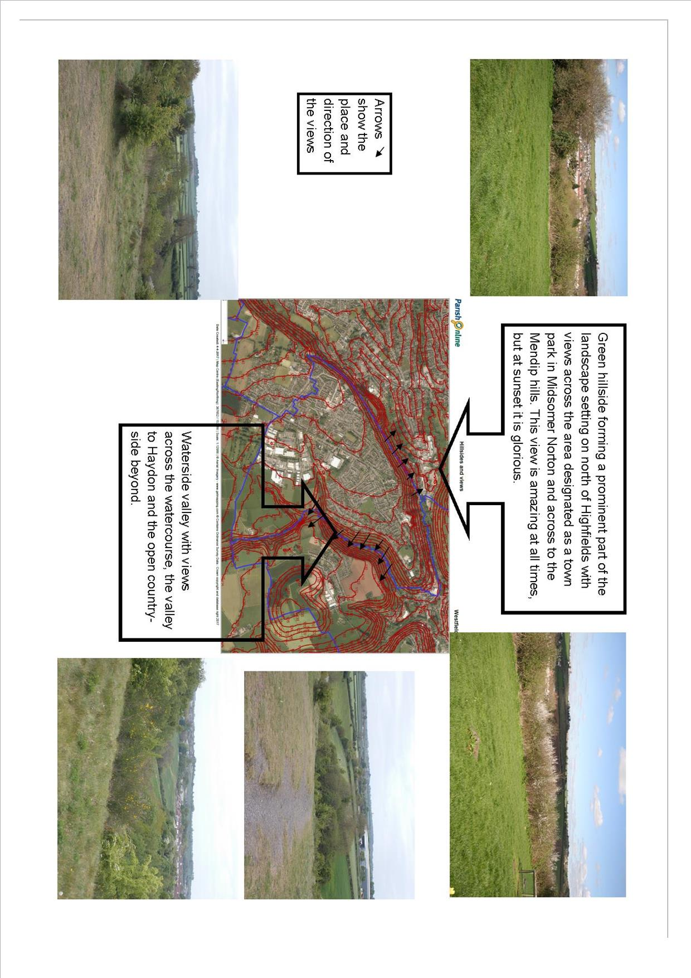
SECTION 3: ASSETS OF COMMUNITY VALUE AND PRESERVING THE HISTORIC ENVIRONMENT
Proposed Asset of Community Value | Reason
Railway Inn, as outlined in the Preserving Heritage Section | For its community value, it is the only remaining public house in Westfield.
Pill Boxes (6), engine house and pit pony stables as outlined in the Preserving Heritage Section | For their historic value, reflecting both the mining heritage and the wartime efforts to protect infrastructure.
Police Station, Wells Road | For the value it would have as a community building, should it no longer be used as a police station.
Westfield Methodist Chapel, St Hugh’s Church and St Peter’s Church | For their historic value and their value as community buildings, should they no longer be used as churches.

Policy 7: Preserving the assets of community value
This policy identifies in the table above the key Assets of Community Value. There will be a presumption in favour of safeguarding them from any adverse proposal which would result in their loss.
Alternative Policy 7a - No additional policy - rely on the National Planning Policy Framework and any policies that may be in the emerging B&NES Placemaking Plan.
Alternative Policy 7b Do you have different ideas for this important policy? We would really like to hear your comments and thoughts. Please continue on a separate sheet if space here does not allow.

QUESTION - Please indicate your preference

Policy 7

Policy 7a

Policy 7b

QUESTION – Are there any other assets which you feel should be registered for their community value? Can you give reasons why?
Should ‘The Shambles’ as a gateway building be preserved due to its historic significance? As shops or as cottages?

Policy 8 Preservation of the Historic Environment
1. Our Neighbourhood Plan supports the preservation, protection and enhancement of our historic built environment by supporting only development within the Conservation Areas which preserves or enhances those elements which contribute to its special character.
2. The Neighbourhood Plan supports the safeguarding of the pill boxes, engine house, pit pony stables, Westfield Methodist Chapel, St Hugh’s Church and St Peter’s Church from any adverse proposal which would result in their loss.
Alternative Policy 8a - No additional policy - rely on the National Planning Policy Framework and any policies that may be in the emerging B&NES Placemaking Plan.
Alternative Policy 8b Do you have different ideas for this important policy? We would really like to hear your comments and thoughts. Please continue on a separate sheet if space here does not allow.

QUESTION - Please indicate your preference

Policy 8

Policy 8a

Policy 8b

Question – Are there any other assets which you feel should be preserved for their historic value? Can you give reasons why?

SECTION 4: EMPLOYMENT, INDUSTRY AND JOBS
The Plan will help businesses both create and preserve existing jobs by:
- Making sure that existing employment sites are kept for employment use wherever possible
- Supporting the creation of new business premises in suitable locations.
- Maximise the potential of B&NES Enterprise Zone proposals
- Protecting the dynamic vitality of Westfield, eg. by encouraging small business.
- Supporting new mixed use developments, so that where appropriate, people can combine work and home life.
- Encouraging appropriate and sustainable green tourism activities.
Policy 9 Development of employment

An expansion of Westfield Industrial Estate would be supported subject to the following criteria:

- The proposal demonstrates that it would not harm the surrounding landscape and the wider setting of Westfield.
- The proposal demonstrates that it would not harm the ecological setting of the site.
- The proposal provides a fully researched Travel Plan, including the changes to HGV traffic volumes and routing, and the requirement of employees to commute with emphasis on journey lengths and potential utilisation of public transport, opportunities for cycling, pedestrian links .

Alternative Policy 9a - No additional policy - rely on the National Planning Policy Framework and any policies that may be in the emerging B&NES Placemaking Plan.
Alternative Policy 9b Do you have different ideas for this important policy? We would really like to hear your comments and thoughts. Please continue on a separate sheet if space here does not allow.

QUESTION - Please indicate your preference

Policy 9

Policy 9a

Policy 9b

Policy 10 New business development on land already in commercial use will be supported subject to the following criteria:

- The scale and nature of the proposals could demonstrate that it would not harm the amenities or employment potential of adjoining activities
- The scale and nature of the proposals could demonstrate that it would have no significant conflicts with agriculture and other land-use activities.
- The proposal could demonstrate that it would not add significantly to local time related road congestion ie. 6.30am-9am and 4pm-6pm.

Alternative Policy 10a - No additional policy - rely on the National Planning Policy Framework and any policies that may be in the emerging B&NES Placemaking Plan.
Alternative Policy 10b Do you have different ideas for this important policy? We would really like to hear your comments and thoughts. Please continue on a separate sheet if space here does not allow.

QUESTION - Please indicate your preference

Policy 10

Policy 10a

Policy 10b

Policy 11 The provision of any new or additional retail floor-space
- Will be supported if it enhances Westfield’s shopping offer, adding to the mixture of local services
- The location enhances the aspiration for a developing a geographic centre for the community
- The position and nature of the proposal could demonstrate that it would not add significantly to local time focussed road congestion ie. 6.30am-9am and 4pm-6pm.

Alternative Policy 11a - No additional policy - rely on the National Planning Policy Framework and any policies that may be in the emerging B&NES Placemaking Plan.
Alternative Policy 11b Do you have different ideas for this important policy? We would really like to hear your comments and thoughts. Please continue on a separate sheet if space here does not allow.

QUESTION - Please indicate your preference

Policy 11

Policy 11a

Policy 11b

Policy 12 The change of use of business premises

The change of use with national business premises classification e.g. A1, through D2 uses (excluding C classification – housing) will not be permitted unless it can be demonstrated that the on-going use of the premises for these purposes is no longer viable. We expect the following evidence to be submitted – evidence of continued active and effective marketing over a period of 12 months.

Alternative Policy 12a - No additional policy - rely on the National Planning Policy Framework and any policies that may be in the emerging B&NES Placemaking Plan.
Alternative Policy 12b Do you have different ideas for this important policy? We would really like to hear your comments and thoughts. Please continue on a separate sheet if space here does not allow.

QUESTION - Please indicate your preference

Policy 12

Policy 12a

Policy 12b

Our policies aim to strike a balance between these views by supporting small scale employment uses where appropriate and opposing redevelopment of mining waste (batches) where the biodiversity is greatest.

Policy 13 Land Usage Proposals for the use of land or buildings on existing employment sites for uses other than employment purposes will not be permitted unless:

It can be demonstrated that the on-going use of the premises or land for employment purposes is no longer viable. Where an applicant is seeking to demonstrate that an existing employment site is not suitable for continued employment use, the planning application will be required to contain a detailed supporting statement giving evidence of continued active and effective marketing for a period of 12 months that seeks to demonstrate that this is the case.
OR
The alternative proposal would provide demonstrable and ongoing employment benefits to the local community, as evidenced by a supporting statement.

Alternative Policy 13a - No additional policy - rely on the National Planning Policy Framework and any policies that may be in the emerging B&NES Placemaking Plan.
Alternative Policy 13b Do you have different ideas for this important policy? We would really like to hear your comments and thoughts. Please continue on a separate sheet if space here does not allow.

QUESTION - Please indicate your preference

Policy 13

Policy 13a

Policy 13b

Policy 14 Proposals for recreational and tourism activities

Proposals for recreational and tourism activities and facilities will be supported providing that the siting, design and scale of the development could demonstrate that it conserves and enhances the quality of Westfield’s built, natural, conservation and historic environments and provides suitable infrastructure ie parking, inclusive design.

Alternative Policy 14a - No additional policy - rely on the National Planning Policy Framework and any policies that may be in the emerging B&NES Placemaking Plan.
Alternative Policy 14b Do you have different ideas for this important policy? We would really like to hear your comments and thoughts. Please continue on a separate sheet if space here does not allow.

QUESTION - Please indicate your preference

Policy 14

Policy 14a

Policy 14b

SECTION 5: AMENITIES AND INFRASTRUCTURE

The single largest theme emerging from consultation with local people is the need for a community facility in Westfield. As a result the Parish Council commissioned a Feasibility Study which highlighted Westhill Recreation Ground as the most suitable site.
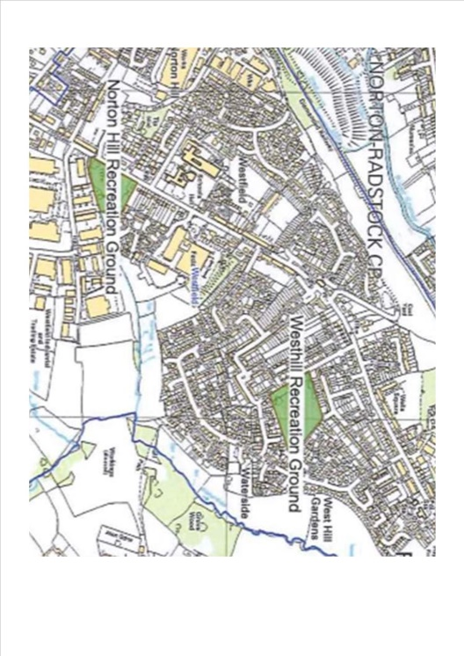

Policy 15 A community facility for Westfield

The Neighbourhood Plan will support a proposal for the development of a parish facility in Westfield to meet the social, recreational and cultural needs of the community, where it is in accordance with other policies within this plan.
Alternative Policy 15a - No additional policy - rely on the National Planning Policy Framework and any policies that may be in the emerging B&NES Placemaking Plan.
Alternative Policy 15b Do you have different ideas for this important policy? We would really like to hear your comments and thoughts. Please continue on a separate sheet if space here does not allow.

QUESTION - Please indicate your preference

Policy 15

Policy 15a

Policy 15b
QUESTION – Do you agree that Westhill Club on West Hill Road is the appropriate site for the development of the Community Centre? YES/NO
How important are the following items to you? Please indicate on a scale of 1-5, with 1 being not needed and 5 being very much needed.

A New Community Centre | 1 2 3 4 5
Café for around 40 | 1 2 3 4 5
Bar | 1 2 3 4 5
Skittle Alley | 1 2 3 4 5
Community meeting room(s) | 1 2 3 4 5
Sports Hall – based on space requirements for basketball court, which will also accommodate 4 badminton courts | 1 2 3 4 5
Changing Rooms, separate for football and sports hall | 1 2 3 4 5
Committee room | 1 2 3 4 5
Westfield Parish Council HQ | 1 2 3 4 5
Further suggestions: | 1 2 3 4 5
Any other comments:

Infrastructure

When planning permission is being considered and granted for development or modification in Westfield, opportunities will be taken to provide facilities and amenities of community value, subject to viability, in accordance with priorities identified in this Neighbourhood Plan or otherwise determined by Westfield Parish Council in consultation with the local community.

QUESTION – How important are the following items of infrastructure to you? Please indicate on a scale of 1-5. 1 being unimportant and 5 being extremely important.

Doctors surgeries and pharmacies expansion to support a growing neighbourhood with increasing health support requirements. | 1 2 3 4 5
Community centre for Westfield. | 1 2 3 4 5
Primary and secondary school expansion to support increase in family units entering the parish. | 1 2 3 4 5
Leisure facilities/social hubs – gyms, cinema, theatre, clubs to support the community spirit and general wellbeing of people in the parish. | 1 2 3 4 5
Hotel accommodation to support increased business activities and facilitate family visiting particularly in light of smaller home sizes. | 1 2 3 4 5
Libraries to provide a function to enable access to learning resources for low income families and the wider population of the parish | 1 2 3 4 5
Colleges/universities to provide an attractive place to grow business through use of apprenticeships, alternative to Bath and Bristol and create opportunity for future entrepreneurs. | 1 2 3 4 5
Care/nursing care homes and Extra Care to support the requirements of an aging population in the parish. | 1 2 3 4 5
Contributions towards road improvements, including new cycle routes and facilities, as well as safer pedestrian crossings. | 1 2 3 4 5
A Westfield Park in the form of a nature trail, linked to the proposed park in Midsomer Norton to allow access to both. | 1 2 3 4 5
Management of the weir on the border with Radstock. | 1 2 3 4 5
Improving the façade and outer area of the local shops at Elm Tree Avenue. | 1 2 3 4 5
Encouraging the development of Heritage Trail in Westfield. | 1 2 3 4 5
Promoting the enhancement of Public Footpath CL24/42 Fosse Way (the old Roman Road). | 1 2 3 4 5
Any other comments:

Policy 16 Developer Contributions
The Neighbourhood Plan identifies the following key infrastructure to be funded via the Community Infrastructure Levy, s.106 or other grant funding.
- Natural Environment – The Neighbourhood Plan supports the conservation, protection and enhancement of our natural environment, by maintaining and extending our green corridors including hedgerows, hillsides, valleys and green space.
- Recreation Grounds - The Neighbourhood Plan will promote greater use of the recreation grounds and play areas within the parish, prioritised to the north of the parish. Developments of over 10 dwellings should include provision for children’s safe play for all ages and abilities.
- Allotments - Where the individual garden size of any development of five or more houses is smaller than the footprint of the actual building, excluding any hard surfaced parking, the Neighbourhood Plan will require specific contributions for the provision of allotments for community use, prioritised on the north side of the Parish.
- Protecting and promoting biodiversity particularly in the green corridors
- Creating signed nature and wildlife trails, including some accessible to wheelchair/pushchair users.
- Improving access to the countryside including safe walking and cycling routes in the Parish and their accessibility by people of all ages to encourage healthier lifestyles.
- Mapping and, wherever possible, linking our local Green Spaces to those of neighbouring parishes and towns, including
- A Westfield Park in the form of a nature trail, linked to the proposed town park in Midsomer Norton to allow access to both
- Management of the weir on the border with Radstock
- Improving the façade and outer area of the local shops at Elm Tree Avenue.
- Preserving the Pit Pony Stables, the Engine Winding House and World War II Pill Boxes, Westfield Methodist Chapel and St Peters Church.
- Promoting the enhancement of Public Footpath CL24/42 Fosse Way.
- Encouraging the development of a Heritage Trail for the Parish.
- Doctors surgeries and pharmacies expansion to support a growing neighbourhood with increasing health support requirements
- A Community centre for Westfield
- Primary and secondary school expansion to support increase in family units entering the parish
- Leisure facilities/social hubs – gyms, cinema, theatre, clubs to support the community spirit and general wellbeing of people in the parish
- B and B/Hotel accommodation to support increased business activities, walking and cycling holidays and facilitate family visiting particularly in light of smaller home sizes.
- Libraries to enable access to learning resources for low income families and the wider population of the parish and give children a love of learning.
- Colleges/universities to provide an attractive place to grow business through developing skills, alternative to those offered in Bath and Bristol and enabling creativity, language skills and leisure interests and create opportunity for future entrepreneurs.
- Care/nursing care homes to support the requirements of an aging population in the parish
- Contributions towards road improvements, including new cycle routes and facilities, as well as safer pedestrian crossings.

Alternative Policy 16a - No additional policy - rely on the National Planning Policy Framework and any policies that may be in the emerging B&NES Placemaking Plan.
Alternative Policy 16b Do you have different ideas for this important policy? We would really like to hear your comments and thoughts. Please continue on a separate sheet if space here does not allow.

QUESTION - Please indicate your preference

Policy 16

Policy 16a

Policy 16b – fo For example, you may like to take away or add to the list,

And still support policy 16. Please tell us what you think.

Policy 17 Broadband Provision
To be supported development proposals for new dwellings, employment premises, and education facilities must make provision to connect to the internet, to the latest industry standard and with realistic future proof upgrades available (demonstrated through a 'Connectivity Statement' provided with relevant planning application).

Alternative Policy 17a - No additional policy - rely on the National Planning Policy Framework and any policies that may be in the emerging B&NES Placemaking Plan.
Alternative Policy 17b Do you have different ideas for this important policy? We would really like to hear your comments and thoughts. Please continue on a separate sheet if space here does not allow.

QUESTION - Please indicate your preference

Policy 17

Policy 17a

Policy 17b
X

SECTION 6: HIGHWAYS
Drainage

Policy 18 Drainage – surface water flooding on the A367
Development affecting surface water flooding on the A367 will not be supported.
Alternative Policy 18a - No additional policy - rely on the National Planning Policy Framework and any policies that may be in the emerging B&NES Placemaking Plan.
Alternative Policy 18b Do you have different ideas for this important policy? We would really like to hear your comments and thoughts. Please continue on a separate sheet if space here does not allow.

QUESTION - Please indicate your preference

Policy 18

Policy 18a

Policy 18b

Traffic

All proposals for significant new development which have an impact on known traffic hazards must make provision for appropriate mitigation or improvement measures to improve road safety.

Policy 19 Traffic hazards
Where proposed developments in Westfield in the vicinity of known traffic hazards are being considered a Traffic Impact Assessment is to be undertaken. All proposals for significant new development which have an impact on known traffic hazards, or potential to create new ones, must make provision for appropriate mitigation or improvement measures to improve road safety.

Alternative Policy 19a - No additional policy - rely on the National Planning Policy Framework and any policies that may be in the emerging B&NES Placemaking Plan.
Alternative Policy 19b Do you have different ideas for this important policy? We would really like to hear your comments and thoughts. Please continue on a separate sheet if space here does not allow.

QUESTION - Please indicate your preference

Policy 19

Policy 19a

Policy 19b

QUESTION – Within the Neighbourhood Plan we would list the following. Have we missed anything?
- The pedestrian refuge at the Welton Road junction is situated on a particularly narrow section of road. Cars are parked on the A367 from here up to the Dring and passing these, especially with buses is hazardous. Is it possible to narrow the footpath outside the College?
- Parking times should be restricted at the lay by outside Costcutters due to restricted visibility. The crossing should be better lit, with markings upgraded, possibly LED lights to control light pollution.
- Highfields crossing should be looked at by the Road Safety Engineers
- The cyclists lane outside the Methodist Church hall goes across the path of pedestrians.
- The grass at the top of Elm Tree Avenue could be grass-creted to enable more parking outside the local shops.
- Parking on the A367 at the junction with Waterside Way makes it dangerous for those coming out of the side road and facing vehicles trying to pass the parked cars.
- Parking on Cobblers Way close to the traffic lights means that the lights are triggered needlessly and cars waiting to come out of Cobblers Way have to wait behind the parked cars. Drainage at this location is a serious issue with surface water flooding a recurring feature.
- The pedestrian crossing close to First Avenue should be moved to Old Pit Road because in order to get to the crossing in its current location pedestrians have to first cross First Avenue, which is a wide road, very busy, with lots of HGV’s. Since this is a route to both St Benedicts and Norton Hill School, young people have to navigate this dangerous crossing without any help.
- Is the pedestrian refuge between Charlton Road and Charlton Lane in the right place?
- The safety of the route at Longfellow Road / Ruskin Road for buses, including the road markings.
…. Are there any additional items? Please add them here.

Air Quality

Policy 20 Air Quality
Development proposals must demonstrate that developers have considered the impact of their proposals on air quality and where appropriate, provide an air quality management assessment. Developments which would result in a deterioration of Westfield’s nitrogen dioxide and diesel particulate pollution on the A367 will not be supported.
Alternative Policy 20a - No additional policy - rely on the National Planning Policy Framework and any policies that may be in the emerging B&NES Placemaking Plan.
Alternative Policy 20b Do you have different ideas for this important policy? We would really like to hear your comments and thoughts. Please continue on a separate sheet if space here does not allow.

QUESTION - Please indicate your preference

Policy 20

Policy 20a

Policy 20b

Parking for Domestic Dwellings
Statistics from the Census 2011 show that properties in our area have more vehicles per dwelling than in other areas of BANES and the UK. For example 3.3% of Westfield households have 4 or more cars compared to 2.5% in BANES and 1.9% in England. 7.9% have three cars, compared with 6.1% in BANES and 5.5% in England and 33% have two cars compared with 27.1% in BANES and 24.7% in England.
Policy 21 Parking – Domestic Dwellings
Parking standards should ensure off street parking and meet the following standards. A minimum of two spaces per dwelling, one of which could be a garage, and 0.5 spaces for visitors.
Alternative Policy 21a - No additional policy - rely on the National Planning Policy Framework and any policies that may be in the emerging B&NES Placemaking Plan.
Alternative Policy 21b Do you have different ideas for this important policy? We would really like to hear your comments and thoughts. Please continue on a separate sheet if space here does not allow.

QUESTION - Please indicate your preference

Policy 21

Policy 21a

Policy 21b

Thank you! We are so grateful that you have taken the time to complete this consultation

Map of Westfield
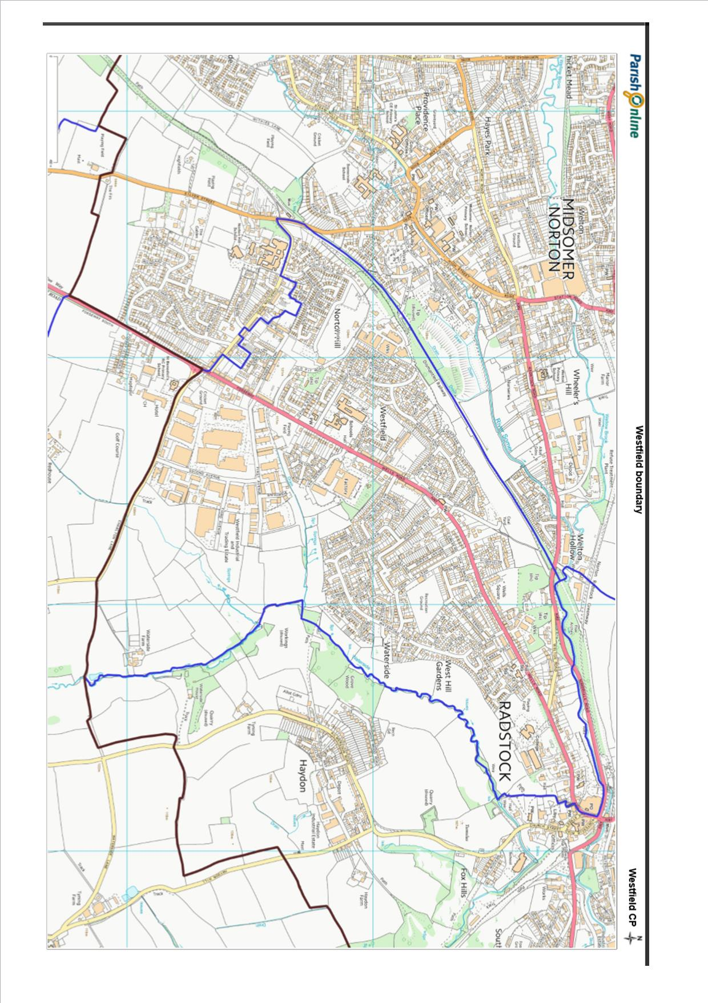
GLOSSARY
Affordable housing - Housing that meets the needs of households whose income does not allow them to rent or buy at prevailing local market prices. It can include social rented housing i.e. rented housing owned and managed by local authorities or Registered Social landlords for which guideline target rents are determined through the national rent regime or intermediate housing where housing prices and rents are above social rent but below market prices or rents.
Backland site - 'Landlocked' sites behind existing buildings, such as rear gardens and private open space, usually within predominantly residential areas. Such sites often have no street frontages.
Brownfield site - an area of land or premises that has been previously used, but has subsequently become vacant, derelict or contaminated. This term derived from its opposite, undeveloped or 'greenfield' land.
Community Infrastructure Levy (CIL) - The Community Infrastructure Levy is a planning charge, introduced by the Planning Act 2008 as a tool for local authorities in England and Wales to help deliver infrastructure to support the development of their area. It came into force on 6 April 2010 through the Community Infrastructure Levy Regulations 2010.
Infill development - The filling of small gaps within existing development e.g. the building of one or two houses on a small vacant plot in an otherwise extensively built up frontage. The plot will generally be surrounded on at least three sides by developed sites or roads.
Grass-crete - Concrete that has a defined pattern of voids achieved through the use of a disposable form that once removed and replaced with stone or grassed soil allows water to pass through the concrete.
Greenbelt - Areas of land where development is particularly tightly controlled. The purposes of Green Belt are to check the unrestricted sprawl of large built-up areas; to prevent neighbouring towns from merging into one another; to assist in safeguarding the countryside from encroachment; to preserve the setting and special character of historic towns; and to assist in urban regeneration by encouraging the recycling of derelict and other urban land.
Green corridor - Green corridors can link housing areas to the national cycle network, town and city centres, places of employment and community facilities. They help to promote environmentally sustainable forms of transport such as walking and cycling within urban areas and can also act as vital linkages for wildlife dispersal between wetlands and the countryside.
Housing development boundary - A line controlling and identifying the limits to developments for an individual area. The line is tightly defined around the housing of the area; it will include existing commitments to build development, and land within residential curtilages except large gardens or other open areas which are visually detached from the settlement. It excludes: Playing fields or open space at the edge of settlements (existing or proposed) • Isolated developments which are physically or visually detached from the village (including farm buildings or agricultural buildings on the edge of the settlement which relate more to the countryside than the settlement) • Large gardens and other open areas which are visually open and relate to the open countryside rather than the settlement • Large gardens or other areas whose inclusion or possible development would harm the structure, form and character of the village • Areas where development and intensification would harm the character of the village or would have an un-acceptable impact on the highway or on the character and landscape • Significant employment sites that are important in providing sources of local employment HDBs do not need to be continuous. It may be appropriate given the nature and form of village to define two or more separate elements.
Holistic design - An approach that emphasizes the functional relationship between the various building parts and the facility as a whole. May include protection of the Earth's resources, as well as an element of spirituality, aiming to create spaces that enrich the quality of the environment and the lives of those who use the building.
Pedestrian refuge - A refuge island, also known as a pedestrian refugeor pedestrian island, is a small section of pavement or sidewalk, completely surrounded by asphalt or other road materials, where pedestrians can stop before finishing crossing a road.
S.106 funding - Planning obligations, also known as Section 106 agreements (based on that section of The 1990 Town & Country Planning Act) are private agreements made between local authorities and developers and can be attached to a planning permission to make acceptable development which would otherwise be unacceptable in planning terms. The land itself, rather than the person or organisation that develops the land, is bound by a Section 106 Agreement, something any future owners will need to take into account.

